

Coney Hill Cemetery & Crematorium

Coney Hill Road

Gloucester

GL4 4PA

**CEMETERIES AND CREMATORIUM**

**FEES AND CHARGES**

**1st APRIL 2023 UNTIL 31st MARCH 2024**

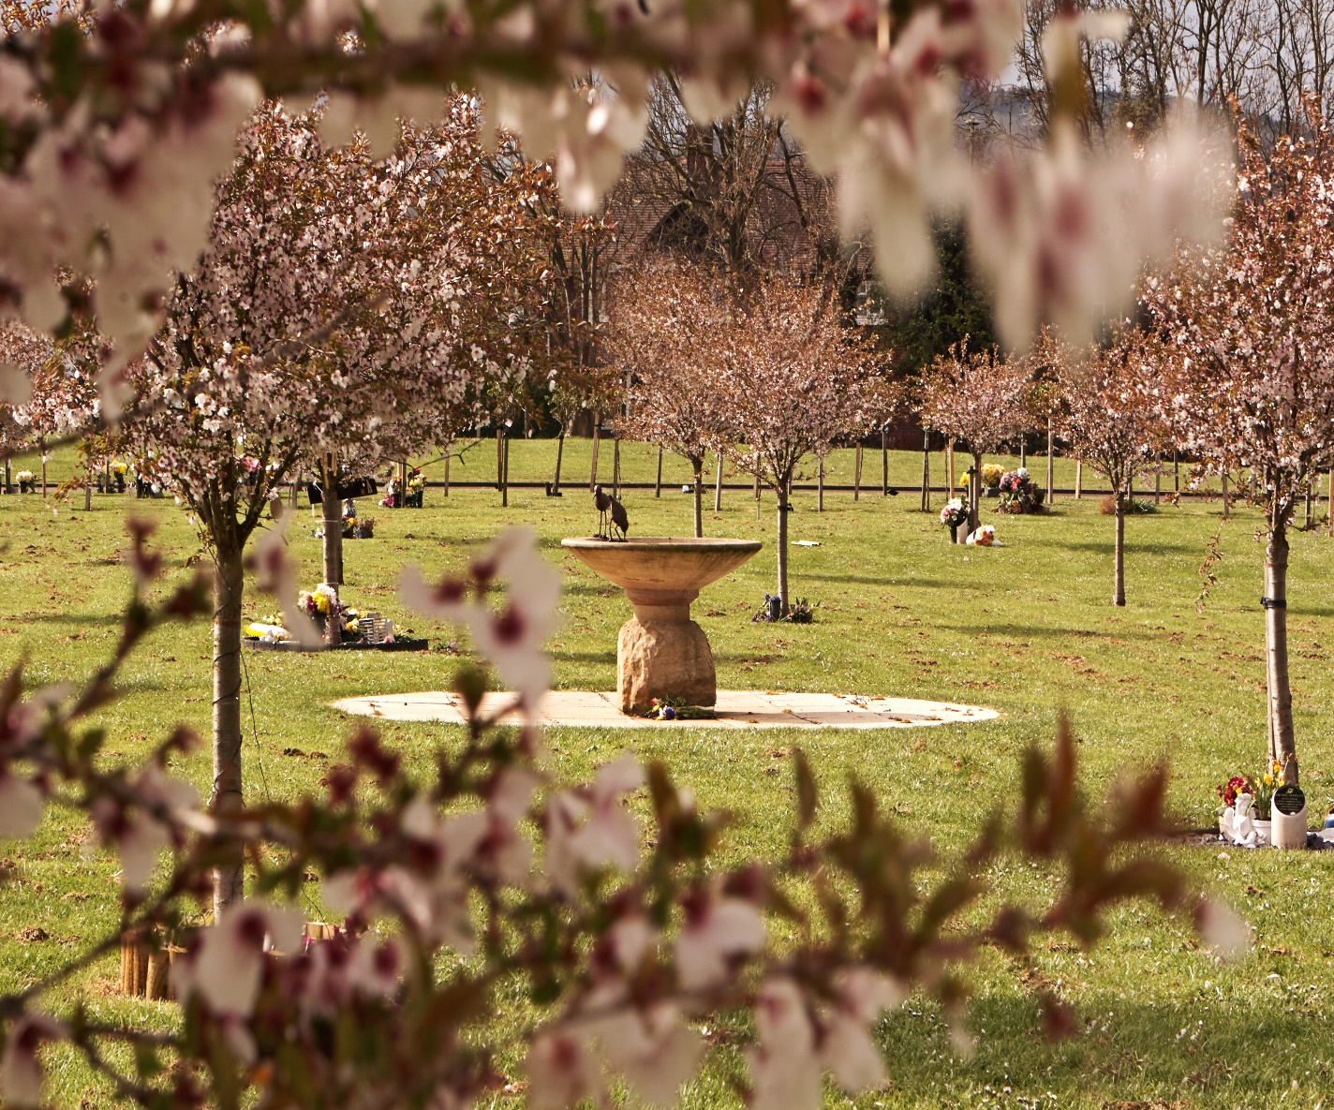

Tel: 01452 396902

E-mail: crematorium@gloucester.gov.uk

www.gloucester.gov.uk

**CEMETERIES**

|  |  |  |  |  |
| --- | --- | --- | --- | --- |
|  | **Purchase of Burial Rights** | | **£** | |
|  | Exclusive Right of Burial for 50 years | | 791.00 | |
|  | for 75 years | | 1202.00 | |
|  | for 99 years | | 2002.00 | |
|  | Woodland Burial All-inclusive charge including Interment | | **1826.00** | |
|  | Any bricked grave* | | 10056.00 | |
|  | **Interment Fees** | |  | |
|  | Stillborn child or child whose age at time of death did not exceed 3 months (to a depth not exceeding 5ft.) | | 79.00 | |
|  | Child who at the date of death had exceeded 3 months but had not attained his/her 17th birthday (to a depth not exceeding 5ft.) | | 279.00 | |
|  | Person who at the date of death attained his/her 17th birthday (to a depth not exceeding 5ft.) | | 802.00 | |
|  | Person who at the date of death attained his/her 17th birthday (to a depth not exceeding 7ft.) | | 1154.00 | |
|  | Extra depth – 7ft. to 9ft. | | 507.00 | |
|  | Coffin or Casket exceeding 7ft 2ins long or exceeding 32ins wide – additional cost of shoring extra wide casket, plus wooden shoring. | | 1121.00 | |
|  | Coffin or Casket exceeding 7ft 2ins long or exceeding 32ins wide – additional cost of shoring in a re-open grave space when next door is not lost. | | 335.00 | |
| **\*includes V.A.T. at standard rate of 20%** | |

**NOTE:**

Fees numbered 1 and 2 above are not payable by the next of kin Gloucester City Council will claim the fee from the Children’s funeral fund. Where a grave is purchased and dug for three and the first interment is that of a child qualifying for free burial, the fee payable will be £1154.00 less the appropriate child fee.

Fees or other services, e.g “Exclusive Right of Burial”, Use of chapel and use of organ etc. remain payable in accordance with those specified overleaf.

|  |  |  |  |  |
| --- | --- | --- | --- | --- |
|  | **Family Backfill** | | **£** | |
|  | Family backfill 5ft for one  Family backfill 7ft for two  Family backfill 9ft for three | | 134.00  205.00  267.00 | |
|  | **Interment of Cremated Remains into a Grave** | |  | |
|  | In an earth grave where the Exclusive Right of Burial has been purchased  Interment of two sets of cremated remains at the same time and location | | 252.00  378.00 | |
|  | To pour ashes into a grave where cremation took place at Gloucester  To pour ashes into a grave where cremation did not take place at Gloucester | | 61.00  71.00 | |
|  | **New Cremated Remains Garden** | |  | |
|  | Charges for purchase of Burial Rights for Cremated Remains only  Interment fee ( applicable in addition to the above charge)  Permission for Memorial | | 312.00  252.00  156.00  720.00 | |
|  | **Use of Chapel for Burial and Memorial Services** | |  | |
|  | Us of Chapel for Burial Service  Use of organ | | 252.00  26.00 | |
|  | **Assignment of Burial Rights** | |  | |
|  | Grave Ownership Transfer | | 43.50 | |
|  | **Memorials etc. (for the right to erect or place)** | |  | |
|  | Headstone not exceeding 3ft in height  Vase/Block or quarried stone no exceeding 10” x 10” x 10” (free standing)  Each additional inscription after the first  Raised stone 18” x 18” x 4” with/ without flower container | | 354.00  100.00  100.00  156.00 | |
|  | **Grave Maintenance** | |  | |
|  | Keeping tidy per grave annually*  Keeping tidy and planting grave annually*  Keeping tidy C.W.G.C. Graves per grave annually*  Search Fees* | | 109.00  161.00  9.50  54.00 | |
| **\*includes V.A.T. at standard rate of 20%** | |

**CREMATORIUM**

|  |  |  |
| --- | --- | --- |
|  | **All services for Persons who at the date of death had attained his/her 17th birthday** |  |
|  | Sunrise Cremation service 10-minute service (between 9:00 – 10:00am)  Attended or non - attended  Classic Cremation Service - 20-minute service, 5 minutes for entry and 5 minutes for exit  45 Minute Cremation Service – 30-minute service, 5 minutes for entry and 5 minutes for exit  Double Cremation Service – One Hour – 50 Minute Service 5 minutes for entry and five minutes for exit  4.00pm Cremation Service additional charge extra  Cremation of body parts (when the cremation took place elsewhere) | 487.00  997.00  1100.00  1288.00  154.00  45.00 |
| 1 | Stillborn child or child whose age at time of death did not exceed 3 months | 80.00 |
| 2 | Child who at the date of death had exceeded three months but had not attained his/her 17th birthday | 155.00 |
|  | Use of Chapel for Burial or Memorial Service  Use of Organ | 252.00  26.00 |
|  | **Medical Referees Fees** | 63.00 |
| **All above charge includes the medical referee fee, Mercury Abatement Fee**  **Fees numbered 1 and 2 above, and Medical Referee Fees related thereto, are not payable by next of kin Gloucester City Council will claim the fees from the Child Funeral Fund.** | | |
|  | **Scattering of Cremated Remains** |  |
|  | Where cremation has taken place at Gloucester Crematorium – by appointment  Where cremation has taken place elsewhere – with or without appointment  Additional Cremation letter | 61.00  71.00  28.00 |
|  | **Crematorium Caskets** |  |
|  | Biodegradable Boxes  Derby Casket (Oak)  Baby Casket (Oak) | 4.00  71.00  71.00 |
|  | Deposit of Cremated Remains per Month after Month | 48.00 |

*\*includes VAT at 20%*

**Multimedia Services Available**

**All service prices include the use of the obitus music library additional fees are applicable has shown below**

|  |  |  |
| --- | --- | --- |
|  | **Visual Tributes-** |  |
|  | **Single Photo**  Simple Slideshow (up to 25 photos played on a loop)  Extra 25 photos for a simple slide show  Family Produced Tribute  Professional photo tribute (up to 25 photos sets to music of your choice)  Physical copy of professional photo tribute (DVD, Blue ray, USB)  Downloadable copy of professional tribute  Themed Tribute – A photo montage with a difference see funeral director | 14.00  44.00  24.00  25.00  78.00  24.00  12.00  95.00 |
|  | **Webcast Services** |  |
|  | **Live webcasting of your loved ones service**  **Live webcasting of your loved ones service, with the option to watch for a further 28 days#**  **Copy of webcasting on DVD, Blue Ray or USB**  **All additional copies on DVD, Blue Ray and USB ( per copy)** | 34.00  51.00  54.00  24.00 |

|  |  |
| --- | --- |
| **20 YEAR MEMORIALS** | |
| **Bronze Plaques (Alphabetical letter refers to image in brochure)** |  |
| Single Bronze Kerb Plaque* **[B]** | 411.00 |
| Single Bronze Kerb Plaque with a Rose Motif* **[B]** | 453.00 |
| Double Bronze Kerb Plaque* **[C]** | 814.00 |
| Woodland Post* **[M]** | 447.00 |
| Single Bronze Tree Plaque* **[F]** | 447.00 |
| Double Bronze Tree Plaque* **[G]** | 865.00 |
| Bronze Heart Tree Plaque* **[L]** | 494.00 |
| Bronze Heart Tree Plaque with Rose Motif* **[L]** | 527.00 |
| Reserved Space on Kerb* | 97.00 |
| **Granite Plaques** | |
| 6” x 4” Granite Plaque* Prices range from kerb plaque with text only to tree plaque with a special motif starting from **[D]** | 562.00 |
| 7 x 5” Granite Tree Plaque* Prices range from a plaque with text only to plaque with a special motif starting from **[H/I/J/K]** | 638.00 |
| Plaque for Planter with inscription only  Plaque for Planter with Motif from | 510.00  539.00 |
| Sanctum 2000* **[N]**  Lawn 8 Planter tablet * | 1573.00  1048.00 |
| **Boutonierre Wall Plaques** | |
| Text Only **[A]** | 566.00 |
| Hand-painted Motif **[A]** | 600.00 |
| Photo Plaque **[A]** | 650.00 |
| **Lavender Lane Memorial Garden** | |
| Purchase of Memorial garden space and permission for a flat tablet (Memorial tablet to be purchased through a registered stone mason) 156.00 | |
| **Granite Memorial Book** | |
| Plaque **[E]** | 407.00 |
| **Benches** | |
| Native Hardwood Garden Seat* | 1375.00 |
| Granite Seat*(Prices Starting from) | 2320.00 |

|  |  |
| --- | --- |
| **Roses/Trees with Plaques** | |
| Flowering Cherry Tree  and Single Bronze Tree Plaque | 821.00  447.00  1268.00 |
| Standard Rose Tree/Shrub/Bush  and Single Tree Plaque | 633.00  447.00  1080.00 |
| Standard Rose Tree /Shrub/Bush  and Bronze Heart Tree Plaque | 633.00  494.00  1127.00 |
| Standard Rose Tree  and Single Granite Plaque (6 x 4 text only) | 633.00  562.00  1195.00 |
| Standard Rose Tree  and Double Bronze Tree Plaque | 633.00  865.00  1498.00 |
| **Lifelong Memorials** | |
| Memory Lane Block | 421.00 |
| **Book of Memory**  2 Line Inscription*  5 Line Inscription*  Book of Remembrance Motif | 82.00  142.00  78.00 |
| **Cremated Remains Keepsakes & Caskets** | |
| Cariad Keepsake  Cheviot, Brecon, Dynasty, Pennine, Mendip,Cairngorn | 53.00 |
| Cariad Full Size Urns  Cheviot, Brecon, Dynasty, Pennine, Mendip,Cairngorn | 216.00 |
| Mandalay Aluminium Urn  Silver, Burgundy, Dark Blue | 62.00 |

|  |  |
| --- | --- |
| **Renewal of Adoption for 20 Years** | |
| Single Plaque | 171.00 |
| Double Plaque | 341.00 |
| Standard Rose Tree or Shrub and Tree Plaque | 274.00 |
| Standard Tree and Tree Plaque | 295.00 |
| Rose Bush and Tree Plaque | 222.00 |
| Renewal of Reserved Space on Kerb* | 100.00 |
| Vase Renewal | 288.00 |
| Sanctum 2000 Renewal | 444.00 |

**The Arbor**

The Arbor building is comprised of two hospitality suites. The Mulberry Room and The Willows Tea Room. The suites provide a tranquil, yet modern setting for families to gather and celebrate the life of a loved one. The Mulberry suite is available for groups of 30 up to 80 people and is fully equipped with a multimedia system where photographs and music of your choice can be played. The Mulberry suite has a fully licensed bar which is stocked with a wide range of bottled beers, ciders and wines.

We have a choice of menus available for wake bookings and you can contact the staff to discuss any requirements for your booking including dietary requirements. You can contact The Arbor staff on 01452 396705 between 09:00am and 4:30pm or email [arborreception@gloucester.gov.uk](mailto:arborreception@gloucester.gov.uk) where one of our staff will be happy to help.

The Willows Tea Room is a bright and airy space which can be booked to cater for private functions from 30 to 40 people where, the tearoom would be closed to the general public.

If the willows tearoom is not booked for a private function it will be open to the general public Monday-Friday from 10:00am to 4:00pm and offers a range of freshly brewed Coffee and Teas, sandwiches, toasties, soup and handmade cakes. We do have highchairs and baby changing facilities and are able to heat baby

food if required.

